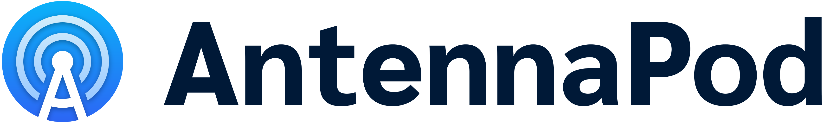
Free podcasting app for Android ‘AntennaPod’ adds new Home screen and gets new look in 3.0 release
Wednesday 15 March 2023 – The new 3.0 release of the free and ad-free podcast app for Android ‘AntennaPod’ introduces a Home screen, giving users an overview of the most important sections and content in the app. This new version will land in users’ hands with a refreshed icon and interface. The updated app is available for download on Google Play and F-Droid from today.
The newly added Home screen introduces a navigation flow that encourages users to discover the content from podcasters they trust and have subscribed to. By drawing on local app data the screen personalizes the app experience while respecting users’ privacy.
The Home screen allows users to quickly pick up episodes they started listening before, find newly released episodes and more. Sections on the screen display content to directly play or open, and provide quick access to the most commonly used screens like the Queue. The Home screen also builds on the Inbox, which was introduced in the previous release and positively received by users.

AntennaPod’s new modern look follows Google’s ‘Material 3’ design system. With it, the app now also supports dynamic colors, a method to match system and app themes with a user’s wallpaper, as well as themed icons, the monochrome app icons introduced in Android 13.
The app also has a refreshed app icon, which features prominently in the splash screen. The evolution of the icon is part of a brand update for the whole project, an exercise lead and contributed by the design company Freehive (known in the open source community from their Gnome 40 release video).
Other improvements in the 3.0 release include the ability to remove a single episode from the playback history, better episode spread while using smart shuffle in the queue, multi-select in the Inbox and the ability to load an episode’s latest chapters if based on the podcasting 2.0 standard.
---
AntennaPod is a volunteer- and donation-based project. It is always open to contributions of all types, such as website and app development, translations, marketing, user research and design.
To find out more about the project, try the app via Google Play or F-Droid, or check the website on www.antennapod.org.
To discover the Home screen in detail, have a look at our blog post Making AntennaPod feel more like Home – personalizing the app experience while respecting your privacy.

